Experiment no: - 2

(PART B: TO BE COMPLETED BY STUDENTS)

Experiment Name: - Data Manipulation Language statements
Aim: - Performing practical by using DML statements statements

Roll. No:C-60 | Name:Avdhut Madhavi
Class : C | Batch: C2
Date of Experiment: | Date of Submission:
Grade:

B.1: Read the given question carefully and write a SQL statement and check the output.
(Put the query and its output after each question.)
After successfully creating the database and tables using DDL statements (CREATE, ALTER, DROP), perform the following DML (Data Manipulation Language) operations:

1.INSERT into Movie_Details

INSERT INTO MOVIE_DETAILS
(movie_id, title, movie_genre, language, duration, rating)
VALUES
(101, 'Inception', 'Sci-Fi', 'English', 148, 8.8),
(102, 'Dangal', 'Drama', 'Hindi', 161, 8.3),
(103, 'Interstellar', 'Sci-Fi', 'English', 169, 8.7),
(104, '3 Idiots', 'Comedy', 'Hindi', 170, 8.4),
(105, 'Drishyam', 'Thriller', 'Hindi', 163, 8.2);

SELECT * FROM MOVIE_DETAILS;

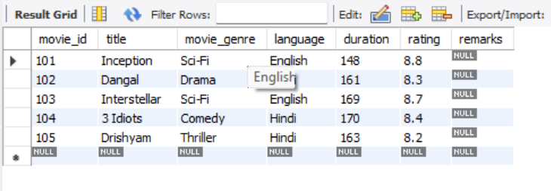

2. INSERT into THEATRE

INSERT INTO THEATRE
(theatre_id, theatre_name, city, phone)
VALUES
(201, 'PVR Cinemas', 'Mumbai', '9000000001'),
(202, 'INOX Central', 'Pune', '9000000002'),
(203, 'Cinepolis', 'Thane', '9000000003'),
(204, 'MovieMax', 'Nashik', '9000000004'),
(205, 'CityPride', 'Pune', '9000000005');

SELECT * FROM THEATRE;

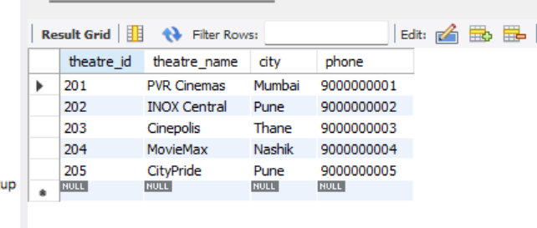

3. INSERT into SCREEN

INSERT INTO SCREEN
(screen_id, screen_name, capacity, theatre_id)
VALUES
(301, 'Screen 1', 150, 201),
(302, 'Screen 2', 120, 202),
(303, 'Screen 3', 180, 203),
(304, 'Screen 4', 100, 204),
(305, 'Screen 5', 200, 205);

SELECT * FROM SCREEN;
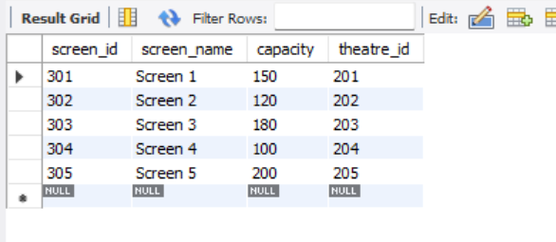

4. INSERT into SHOWTIME

INSERT INTO SHOWTIME
(show_id, movie_id, screen_id, show_date, show_time, ticket_price)
VALUES
(401, 101, 301, '2026-10-11', '10:00:00', 250.00),
(402, 102, 302, '2026-10-11', '13:00:00', 200.00),
(403, 103, 303, '2026-10-12', '16:00:00', 300.00),
(404, 104, 304, '2026-10-12', '19:00:00', 180.00),
(405, 105, 305, '2026-10-13', '21:00:00', 220.00);

SELECT * FROM SHOWTME;

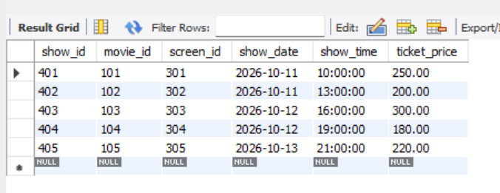

5. INSERT into SEAT

INSERT INTO SEAT
(seat_id, screen_id, seat_number, seat_type)
VALUES
(501, 301, 'A1', 'Premium'),
(502, 302, 'B1', 'Regular'),
(503, 303, 'C1', 'Premium'),
(504, 304, 'D1', 'Regular'),
(505, 305, 'E1', 'Recliner');

SELECT * FROM SEAT;

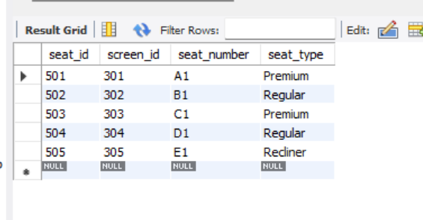

6. INSERT into CUSTOMER

INSERT INTO CUSTOMER
(customer_id, customer_name, email, phone, city)
VALUES
(601, 'Rahul Patil', 'rahul@example.com', '9100000001', 'Mumbai'),
(602, 'Priya Shah', 'priya@example.com', '9100000002', 'Pune'),
(603, 'Amit Naik', 'amit@example.com', '9100000003', 'Thane'),
(604, 'Sneha Rao', 'sneha@example.com', '9100000004', 'Nashik'),
(605, 'Ravi Sharma', 'ravi@example.com', '9100000005', 'Mumbai');

SELECT * FROM CUSTOMER;

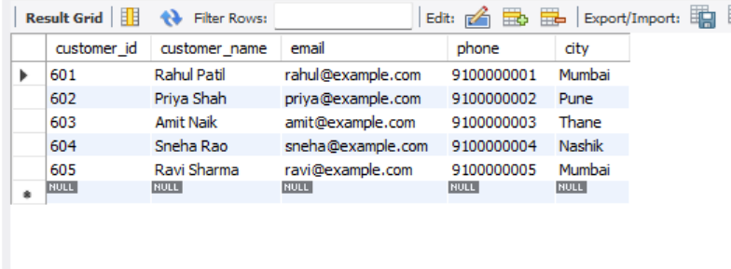

7. Create and Insert into BOOKINGS

CREATE TABLE booking (
booking_id INT PRIMARY KEY,
customer_id INT,
show_id INT,
seat_id INT,
booking_date DATE DEFAULT (CURRENT_DATE),
status VARCHAR(15) DEFAULT 'CONFIRMED',
FOREIGN KEY (customer_id)
REFERENCES customer(customer_id),
FOREIGN KEY (show_id)
REFERENCES showtime(show_id),
FOREIGN KEY (seat_id)
REFERENCES seat(seat_id)
);

INSERT INTO booking
(booking_id, customer_id, show_id, seat_id, booking_date, status)
VALUES
(701, 601, 401, 501, '2026-10-10', 'CONFIRMED'),
(702, 602, 402, 502, '2026-10-10', 'CONFIRMED'),
(703, 603, 403, 503, '2026-10-10', 'CONFIRMED'),
(704, 604, 404, 504, '2026-10-10', 'CANCELLED'),
(705, 605, 405, 505, '2026-10-10', 'CONFIRMED');

SELECT * FROM BOOKING;

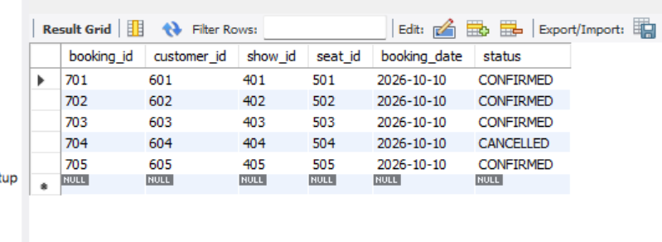

8. Create and Insert into PAYMENT:

CREATE TABLE payment (
payment_id INT PRIMARY KEY,
booking_id INT,
amount DECIMAL(8,2),
payment_method VARCHAR(20),
payment_status VARCHAR(15),
payment_date DATE DEFAULT (CURRENT_DATE),
FOREIGN KEY (booking_id)
REFERENCES booking(booking_id)
);
INSERT INTO payment
(payment_id, booking_id, amount, payment_method, payment_status, payment_date)
VALUES
(801, 701, 200.00, 'UPI', 'SUCCESS', '2026-10-10'),
(802, 702, 250.00, 'Card', 'SUCCESS', '2026-10-10'),
(803, 703, 180.00, 'Cash', 'SUCCESS', '2026-10-10'),
(804, 704, 220.00, 'UPI', 'REFUNDED', '2026-10-10'),
(805, 705, 300.00, 'Card', 'SUCCESS', '2026-10-10');

SELECT * FROM PAYMENT;
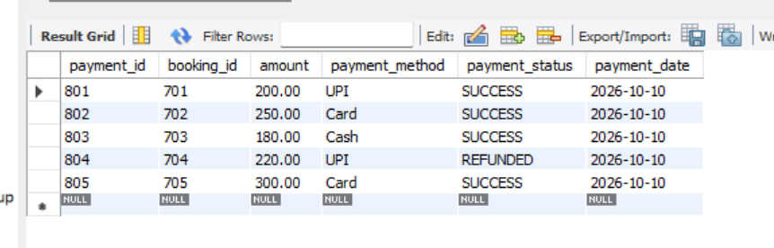

2. UPDATE queries

1. Customer_Details04
A. Update a customer’s city
Change the city of customer 601 to Pune.

UPDATE customer
SET city = 'Pune'
WHERE customer_id = 601;

SELECT * FROM customer;

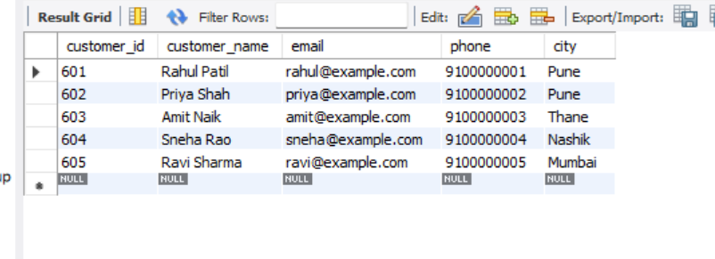

B. DELETE query
A. Delete a specific customer

DELETE FROM customer
WHERE customer_id = 605;

SELECT * FROM CUSTOMER;

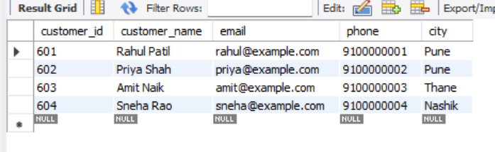

UPDATED EER DIAGRAM:
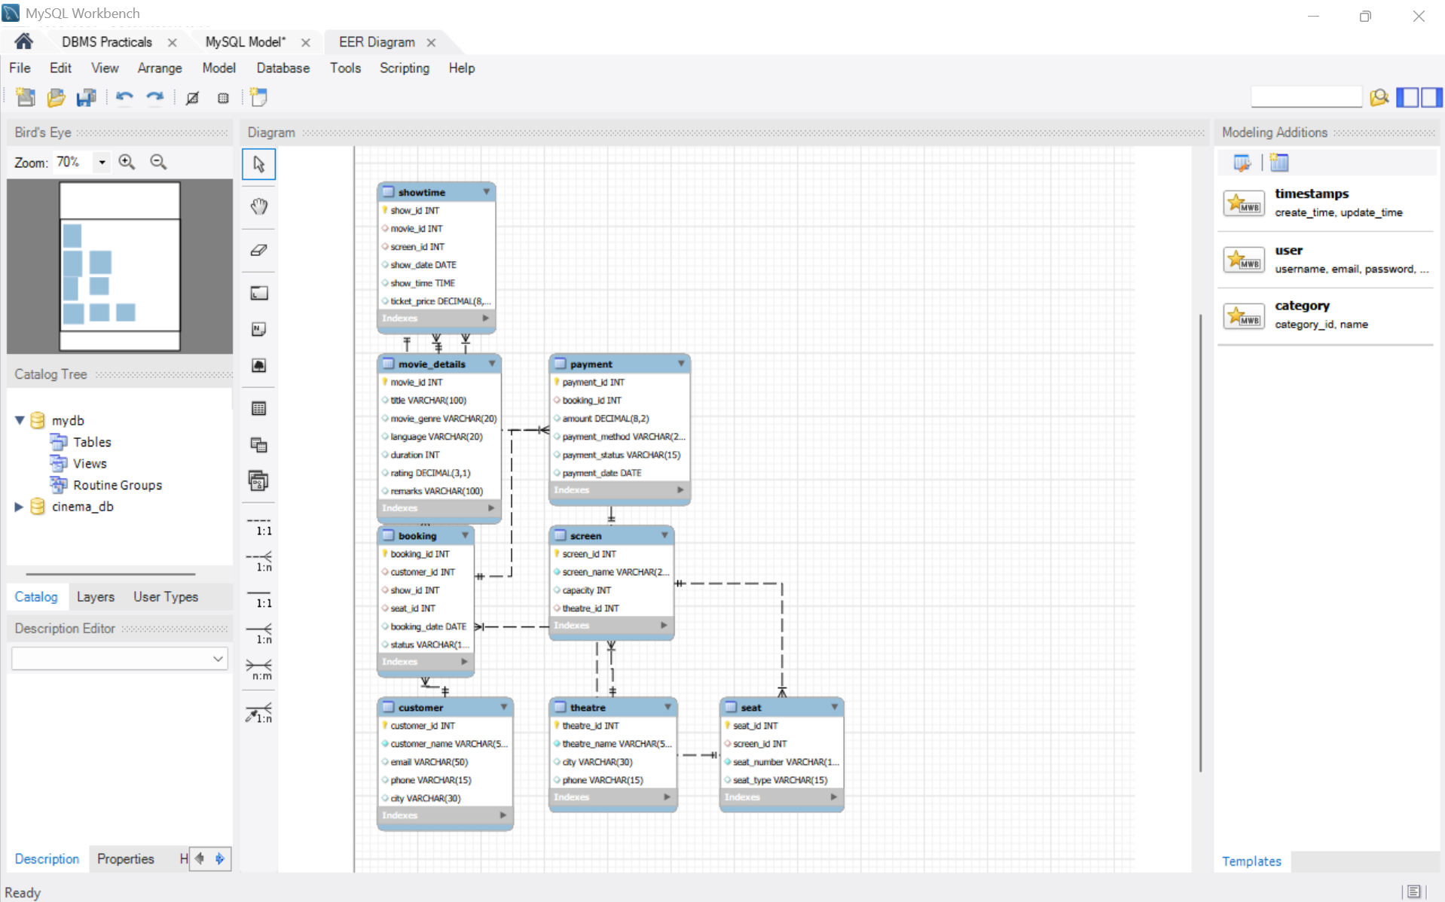

B.2: Write an observation according to the query execution.

Observation: Cinema Ticket Booking System

- Created the required tables for the Cinema Ticket Booking System using DDL statements.
- Inserted records into the tables: movie_details, theatre, screen, showtime, seat, customer, booking, and payment.
- Retrieved table records successfully using SELECT statements.
- Updated customer details and booking statuses using UPDATE statements.
- Deleted selected records using DELETE statements.
- Applied primary-key and foreign-key constraints to maintain data integrity and relationships between tables.
- Used constraints to prevent duplicate primary keys and invalid foreign-key values.
- Observed how foreign-key relationships affect the deletion of records in related tables.

B.3: Write an answer of the following questions

1.What is the difference between DDL and DML?
DDL (Data Definition Language) | DML (Data Manipulation Language)
Used to create, modify, and delete database structures. | Used to insert, update, and delete records in tables.
Deals with tables and other database objects. | Deals with data stored in tables.
Changes the database structure. | Changes the data stored in the database.
Examples: CREATE, ALTER, DROP, TRUNCATE. | Examples: INSERT, UPDATE, DELETE.

2.What is the difference between DELETE, TRUNCATE, and DROP in terms of performance?
DELETE | TRUNCATE | DROP
Removes selected rows or all rows from a table. | Removes all rows from a table. | Removes the entire table.
Supports the WHERE clause. | Does not support the WHERE clause. | Does not support the WHERE clause.
Generally slower for removing all rows. | Generally faster for removing all rows. | Removes both data and table structure.
Keeps the table structure. | Keeps the table structure. | Deletes the table structure and data.
In MySQL, an InnoDB DELETE can be rolled back before committing the transaction. | Generally cannot be rolled back in MySQL because it causes an implicit commit. | Generally cannot be rolled back in MySQL because it causes an implicit commi

